**RobotC Setup:**

Depending on the version of Robot C the IDE (Integrated Development Environment) will be a little different GUI (Graphic, but this guide will focus on how to do things in a similar approach. Here is a picture of the Vex Cortex for reference.

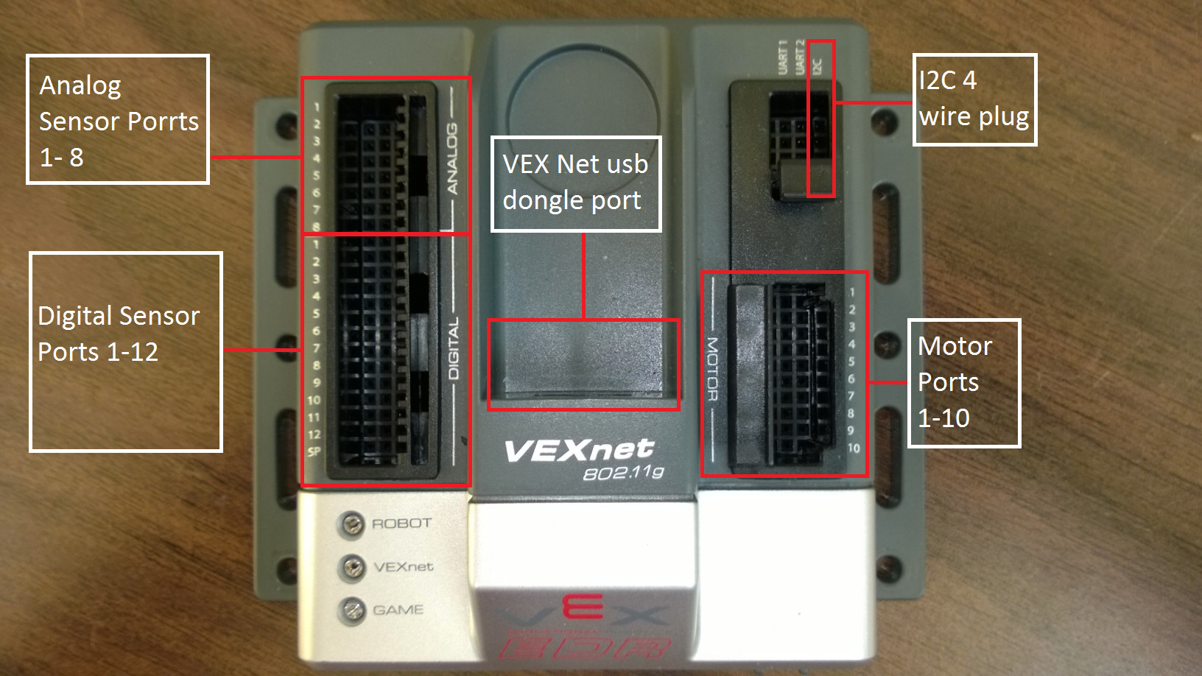

**Setting up a new project / file:**

1. Create a new file which is show below.

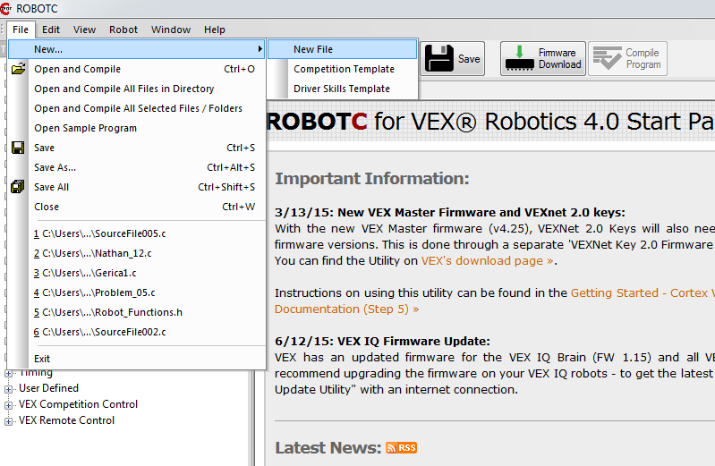

1. If you don’t save the file the IDE will complain and force you to save it, so go ahead and save the file as any name and a location not in the RobotC exe path, because it will complain you do not have permission.

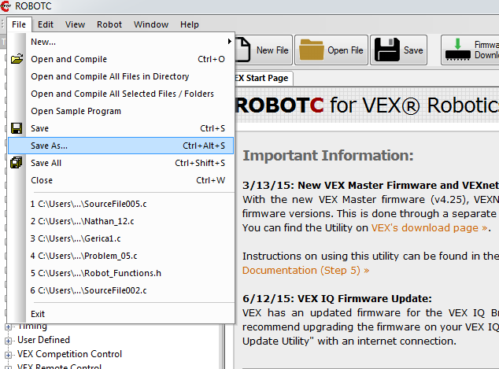

**Adding Sensors and motors:**

The next step will be to setup any motor and sensors you will be using. There will three main tabs you will use in the motor and sensors setup.

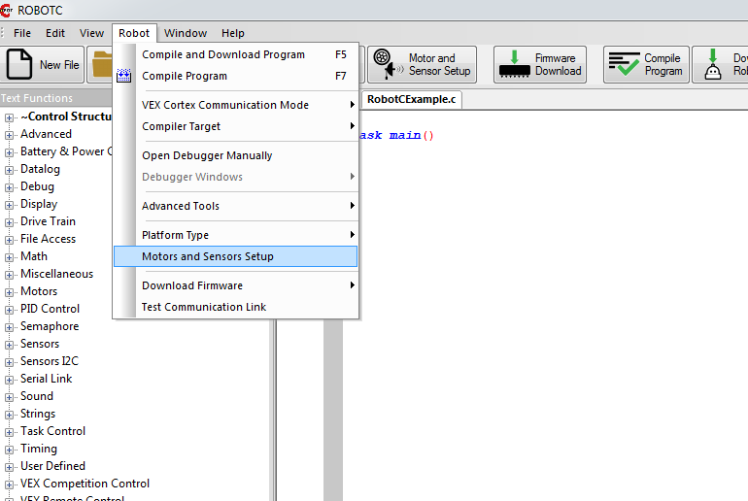

1. This first tab is the motor tab.
   1. Select the motor port for the motor you want to setup up
   2. Name the motor as a variable with no spaces and shouldn’t start with a numerical number.
   3. The type of motor is “Vex 393 Motor” unless told otherwise.
   4. Reversed check box should be checked if when a motor is given a positive value and goes in reverse then you should click the check box which will reverse this behavior. You will find out later when you test the code if it goes in the wrong direction.
   5. Encoder Port should only be changed if using Integrated Motor Encoders. Integrated Motor Encoders use a I2C daisy chain, so the Encoder Port will be I2C_1 if the current motor is plugged in first to the Vex Cortex and I2C_2 if the current motor is the second motor on the chain which would be after the first motor. Don’t use the I2C_Sensor tab when setting up Integrated Motor Encoders just use the motor tab.

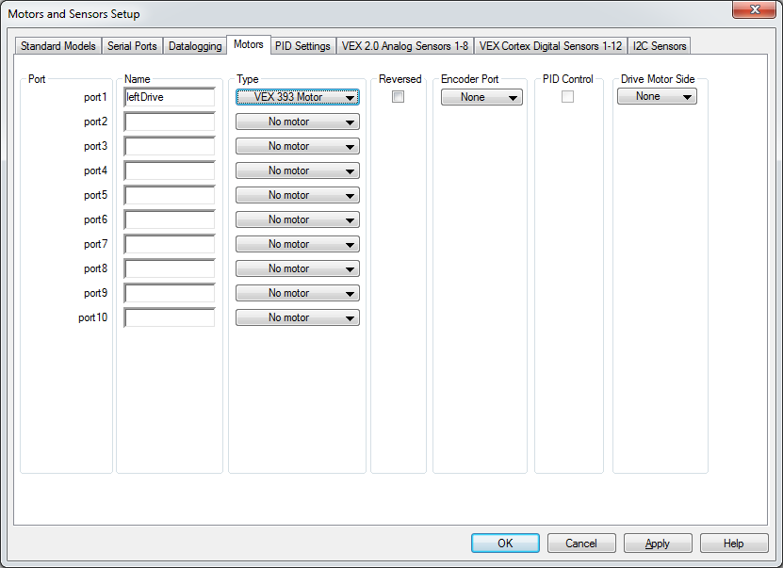

1. The next tab is the VEX analog Sensors. You have several types of sensors you can choose from that you are setting up. Just like setting up motor make sure you don’t name a sensor with spaces or starting with a numerical value. Analog Sensors include:
   1. Potentiometer
   2. Light Sensor
   3. Line Follower
   4. Gyor Sensor
   5. Accelerometer

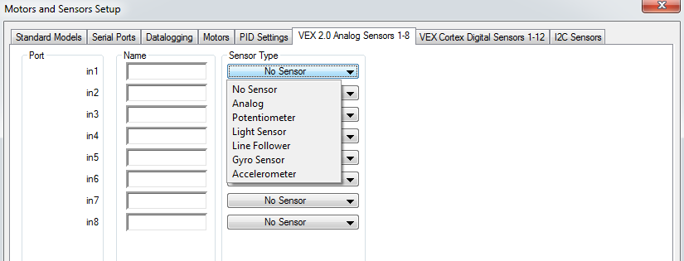

1. The last tab is the Vex digital sensors. Just like motors and analog sensors make sure you don’t use spaces for names and starting with numerical numbers. Digital sensors you can include:
   1. Touch / Button
   2. Quadrature Encoder
   3. LED
   4. Sonar

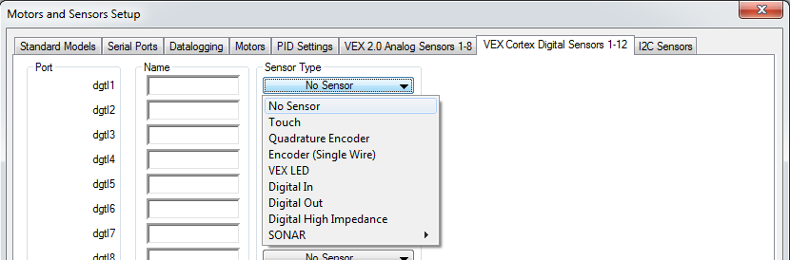

**Compiling and downloading to the robot:**

To compile the program and make sure you have now errors you can press F7 or use the compile button on the robot tab in the RobotC IDE.

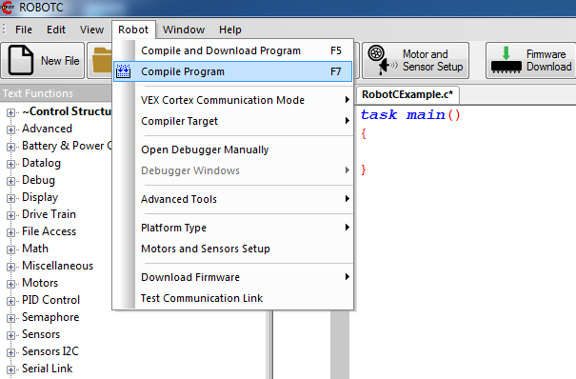

1. When you are ready to download and compile to the Vex Cortex you must plug in the orange USB cable to your computer and the Vex Cortex as shown below.

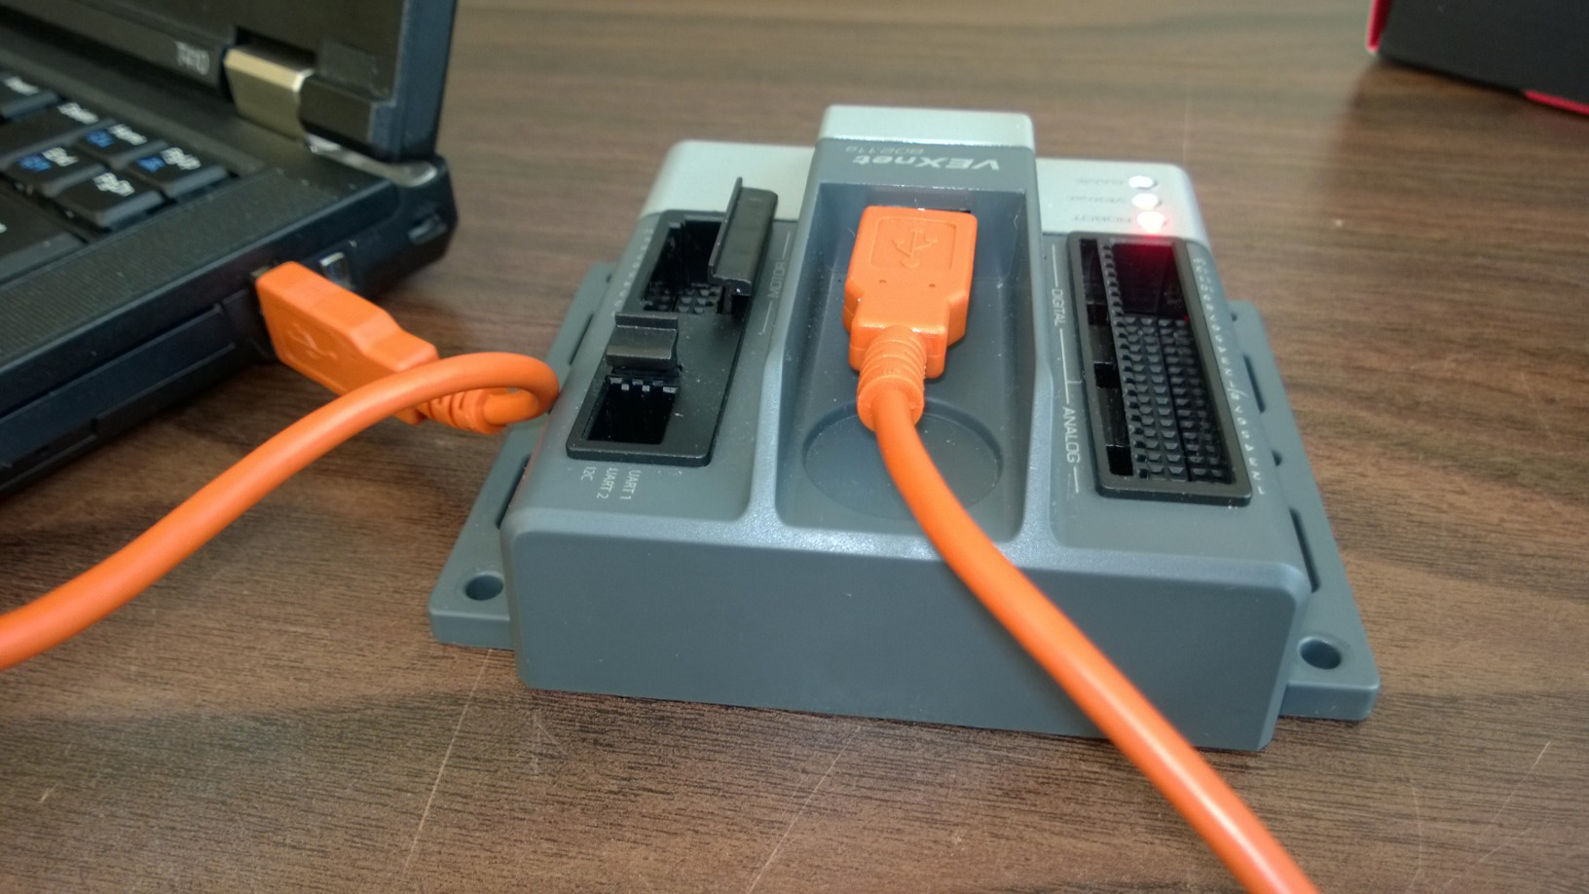

1. Now the computer and Vex Cortex are plugged in you can compile and download the program from the robot tab or by pressing F5.

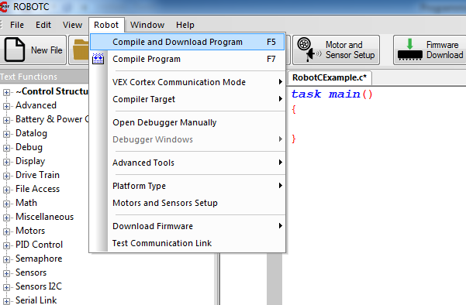

1. Once the program has successfully compiled and downloaded to the Vex Cortex you are able to stop and start the program from the window below.

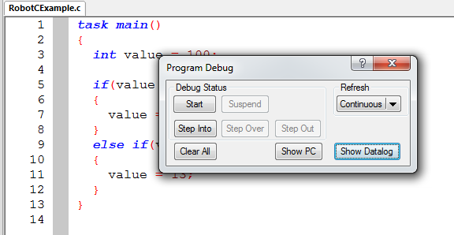

1. You can also setup debug windows for motors, sensors, and timers. You can change the debug windows when you have successfully compiled and downloaded the program to the Vex Cortex.

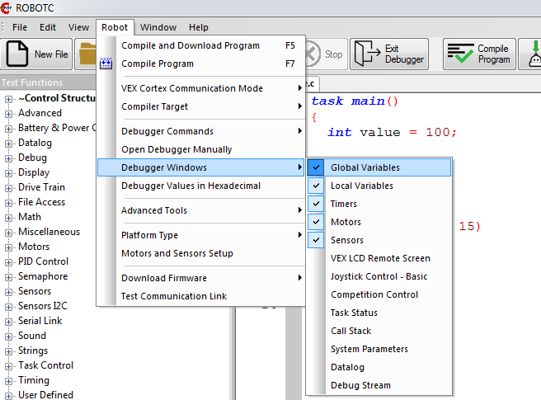

The debug windows will be display bellow in the corresponding tabs.

